**2. Ideation Phase**

|  |  |
| --- | --- |
| Date | 31 January 2025 |
| Team ID | LTVIP2025TMID35678 |
| Project Name | Pattern Sense: Classifying Fabric Pattern using Deep Learning |
| Maximum Marks | 4 Marks |

**2.2 Empathy Map:**

The empathy map created for the Pattern Sense project focuses on the experiences, behaviors, and challenges of a Textile Quality Inspector, a key user of our solution. This step in the ideation phase was essential to deeply understand the user's mindset, goals, frustrations, and environment, ensuring that our deep learning-based solution addresses real and relevant user needs.

By stepping into the inspector’s shoes, we uncovered several critical insights. The user constantly strives for accuracy and speed, yet the current manual inspection process is time-consuming, inconsistent, and prone to human error. They often deal with bulk fabrics, leading to visual fatigue, and rely on subjective judgment, which can result in errors and dissatisfaction from supervisors.

Our empathy map captures what this user thinks, feels, sees, hears, says, and does. It also identifies pains (like mental exhaustion and inconsistency) and gains (like automation, speed, and reliability). These findings directly shaped our solution’s objectives — to build a tool that enables automatic, consistent, and fast classification of fabric patterns.

This empathy-driven approach ensures that Pattern Sense is not just a technically sound product, but one that meaningfully improves the lives of those using it on the ground.

**Empathy Map – Textile Quality Inspector**

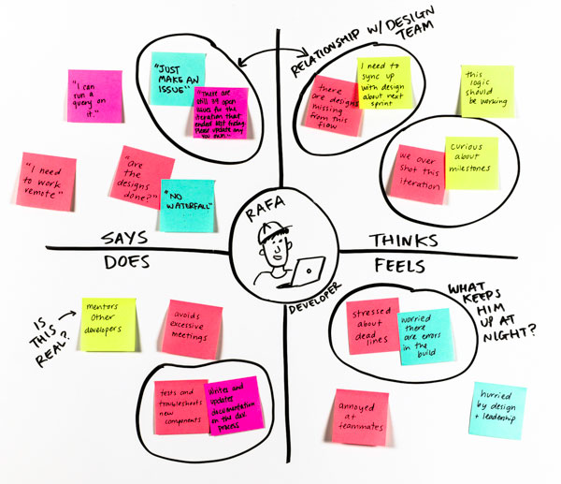

**Think & Feel:**

* Wants the inspection process to be quick and accurate
* Feels under pressure during bulk quality checks
* Thinks automation could help reduce errors
* Worries about missing subtle pattern differences

**See:**

* Large batches of unlabelled fabric rolls
* Visual fatigue from manually checking every roll
* Colleagues manually recording notes

**Say & Do:**

* Often says: “This would be easier with some tool assistance.”
* Expresses frustration over unclear or repetitive patterns
* Uses manual notes and visual comparison techniques
* Double-checks patterns to avoid mistakes

**Hear:**

* Hears supervisors talk about faster output and fewer errors
* Gets feedback from peers about mistakes in pattern detection
* Listens to discussions around automating quality checks

**Pain:**

* Manual inspection is time-consuming and exhausting
* High chances of human error
* Inconsistency in pattern tagging across inspectors

**Gain:**

* Save time and effort with automated assistance
* Consistent, objective pattern detection
* Increased accuracy and job satisfaction